**CRM Guide: Agency Fee (Payable to Agency)**

Finance → Payables → Payable to Agency v2

*A step-by-step visual guide to transferring agency fees and management commissions*

# **Overview**

The Payable to Agency section (also called the Agency Fee page) is where you transfer management fees, letting fees, and other commission amounts from client property accounts into your agency's own account. Unlike paying landlords or contractors, this process moves money that is owed to the agency itself — not to a third party.

The page lists every managed property alongside the agency fees that have been charged but not yet transferred. Each row shows the current property cash balance, the total fees owed (Balance), and the amount that can be transferred right now (Available to Transfer). You select which properties to transfer fees from, adjust amounts if needed, and submit in one action.

# **Understanding the Key Numbers**

**Step 1: Available to Transfer vs. Balance**

There are two important figures shown at the top of the page:

* Available to Transfer — The amount you can move to the agency account right now. This is capped by the actual cash sitting in each property's client account. If a property has outstanding fees of £650 but only £500 in cash (because rent hasn't been fully received yet), only £500 is immediately transferable.
* Balance — The total outstanding agency fees owed across all properties, including amounts that cannot yet be transferred because the property doesn't have sufficient cash. This number will be higher than Available to Transfer when rent has not yet been received for some properties.

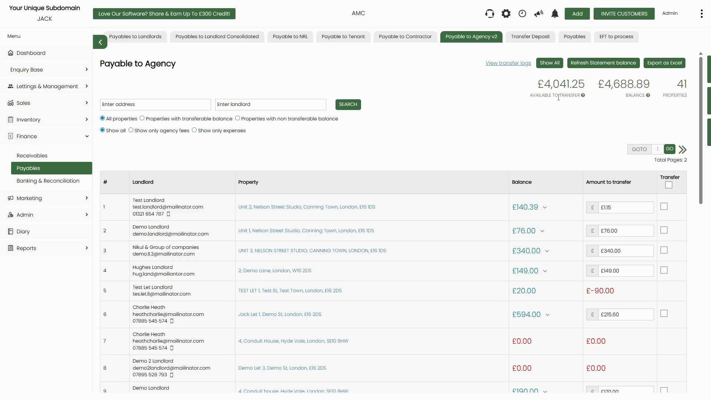

*Figure 1: Payable to Agency page — Available to Transfer (£4,041.25) vs. Balance (£4,688.89) across 41 properties. Each row shows Landlord, Property, Balance (with expand arrow ▼), and editable Amount to transfer*

The video illustrates this concept with a worked example: if a property has a Letting Fee of £250 + Management Fee of £100 + Additional Fee of £300 = total commission of £650, but only £500 in rent received, the Available to Transfer figure will show £500 (capped by available cash), while the Balance will show £650 (total owed).



*Figure 2: Available to Transfer explained — total commission of £650 but immediately transferable amount is capped by the property balance*

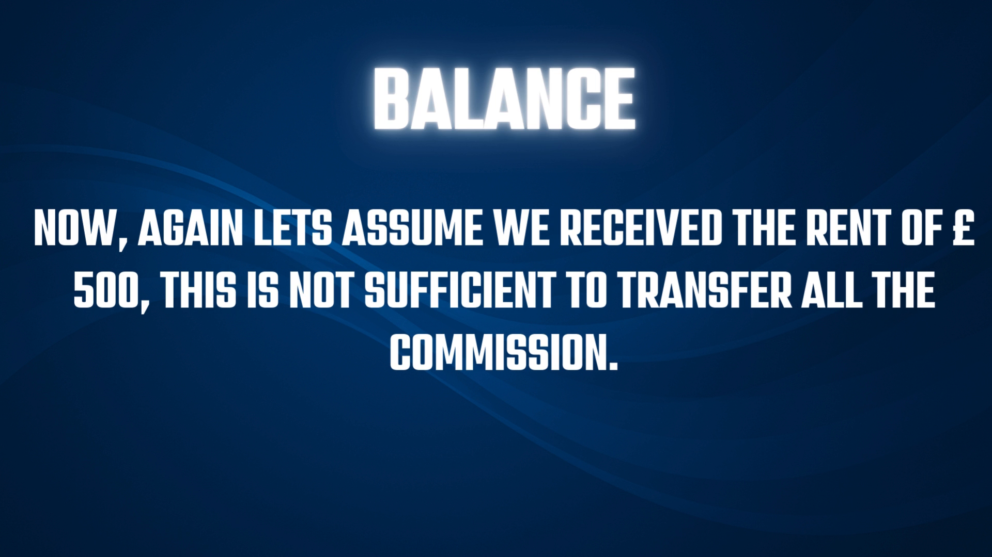

*Figure 3: Balance concept — if rent received is only £500, this is insufficient to transfer all the commission (£650), so the remainder stays in Balance until more rent is collected*

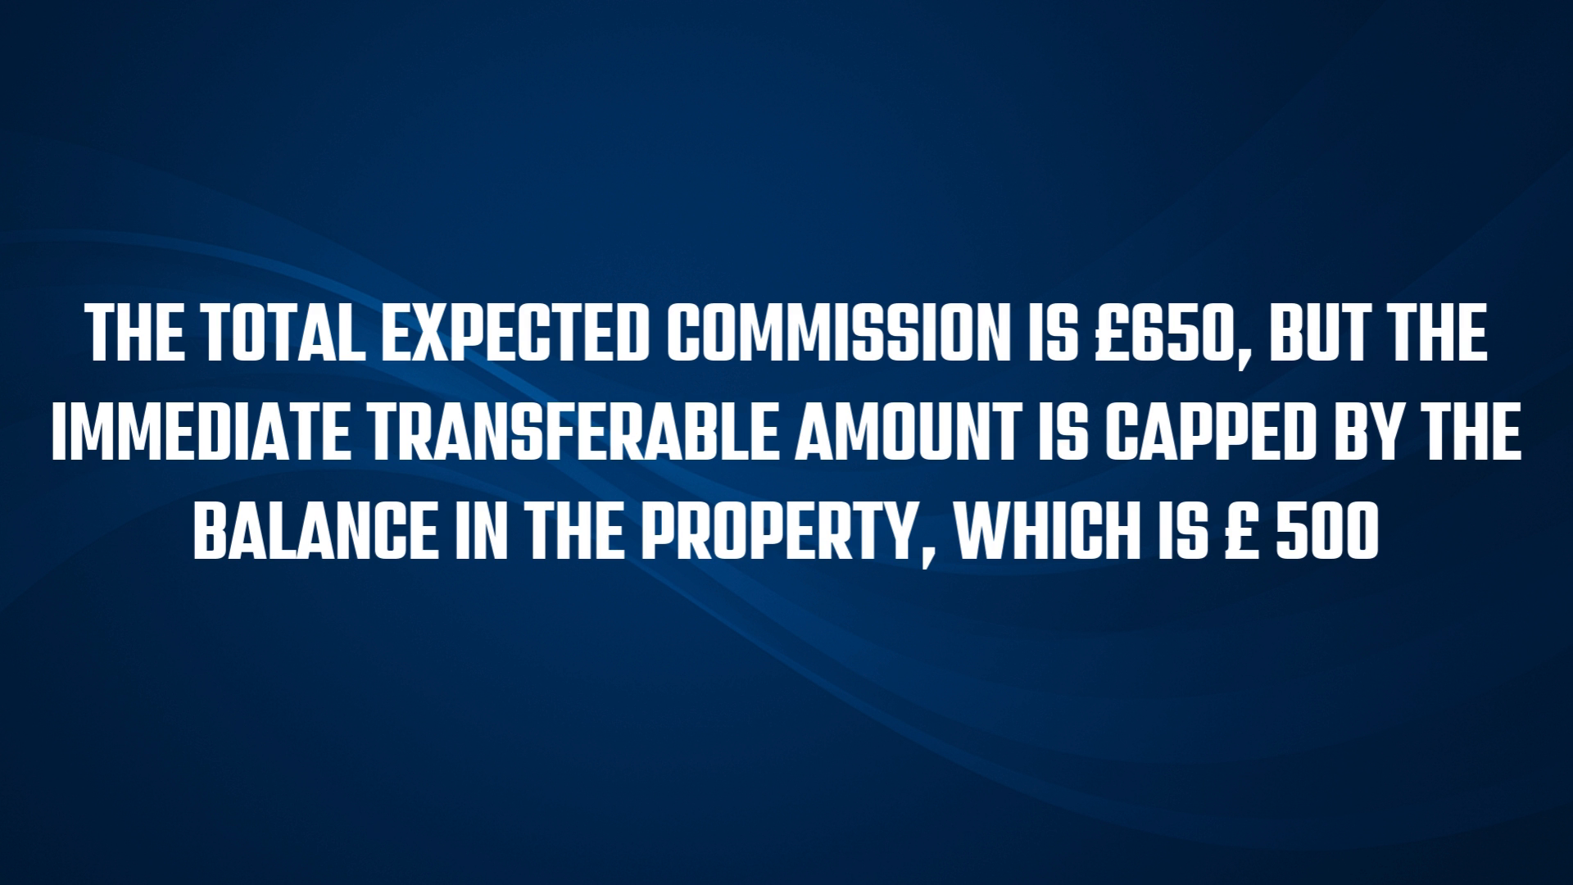

*Figure 4: The total expected commission is £650, but the immediate transferable amount is capped at £500 (the property's current cash balance)*

**📌 Note:** The Balance column will reduce each time you successfully transfer fees. Properties will remain on the list until their outstanding balance reaches zero.

# **Navigating the Payable to Agency Page**

**Step 1: Open the Page**

From the left-hand menu, click Finance → Payables. In the tab navigation at the top, click Payable to Agency v2. When the page loads, it will show a progress dialog counting through all properties (e.g. '13 / 41 — Please wait while we load all Agency payments'). Wait for this to complete before interacting with the list.

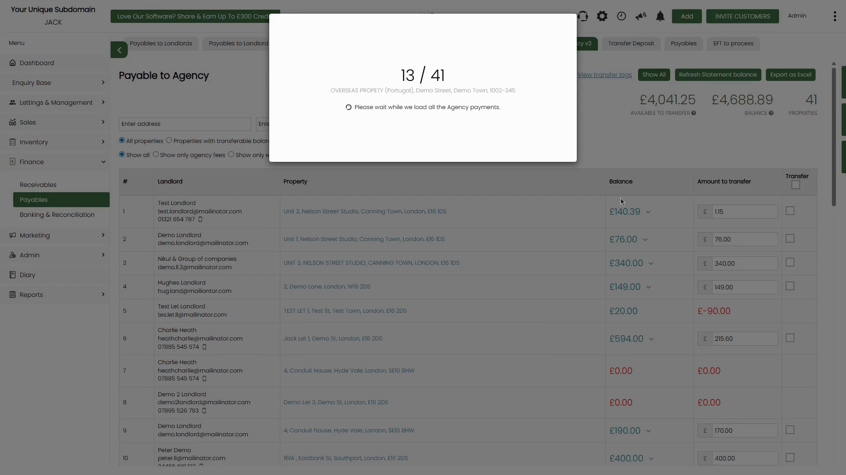

*Figure 5: Loading dialog — '13/41 — Please wait while we load all the Agency payments' — the system is calculating balances across all properties*

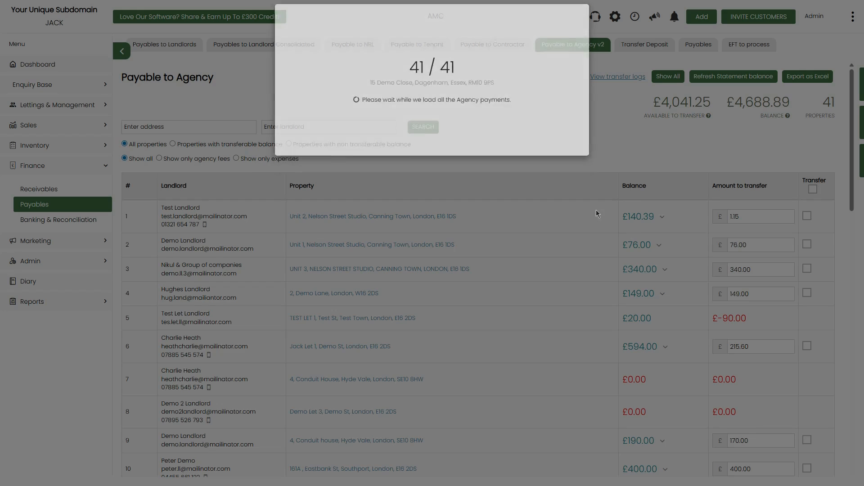

*Figure 6: Loading complete — '41/41' — all property agency balances are now loaded and the list is ready to use*

**Step 2: Understand the Page Layout**

Once loaded, the page shows the full list of properties with outstanding agency balances. The top-right area displays three key summary figures:

* Available to Transfer — the total transferable amount right now across all properties.
* Balance — the total outstanding fees across all properties (including non-transferable amounts).
* Properties — the count of properties with outstanding agency fees.

Below the summary figures is the property list, showing one row per landlord/property combination with the Balance, Amount to transfer (editable), and a Transfer checkbox.

**Step 3: Use the Filters**

Two sets of filter radio buttons appear above the list:

* Property view: All properties | Properties with transferable balance | Properties with non-transferable balance. Use 'Properties with transferable balance' to focus only on properties where a transfer can be made right now.
* Content view: Show all | Show only agency fees | Show only expenses. Use 'Show only agency fees' to hide expense lines and focus purely on commission entries.

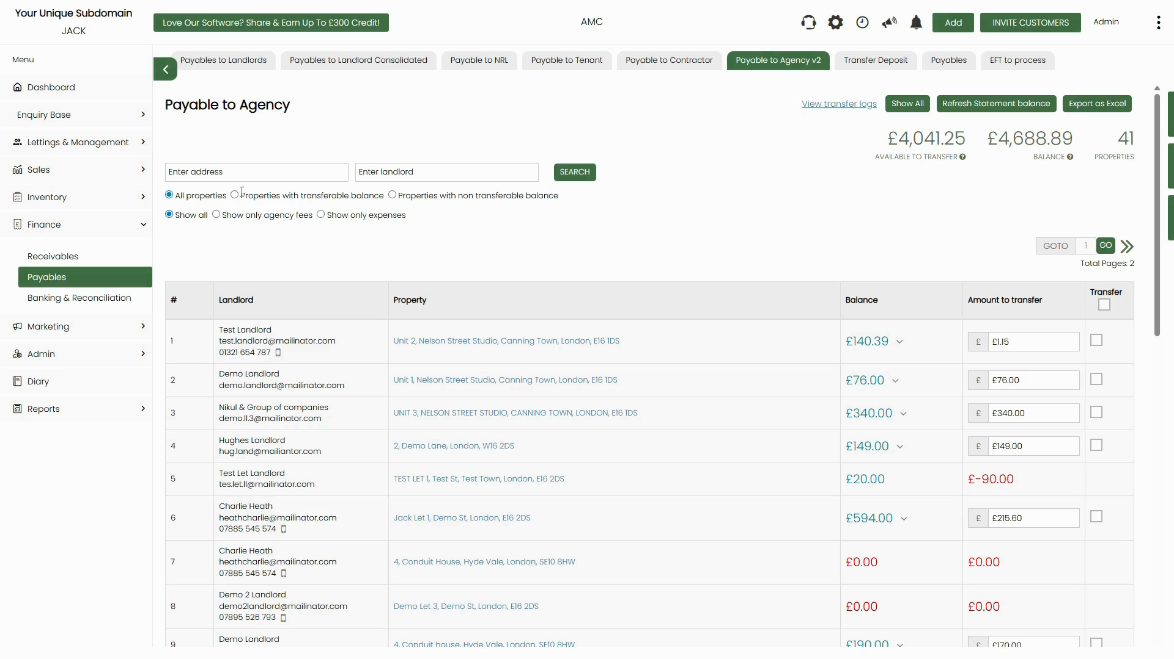

*Figure 7: Filter options — property view filters (top row) and content view filters (bottom row). Switch to 'Properties with transferable balance' to see only actionable rows*

**Step 4: Expand a Row to See Fee Breakdown**

Each row in the list shows the total Balance for that property. To see the individual fee invoices making up that balance, click the expand arrow (▼) next to the Balance figure. A sub-table expands below the row showing each invoice individually with its date, invoice number, description (e.g. 'Management fee 01.10.2025 to 31.10.2025'), amount, allocated amount, and a Transfer checkbox for each line.

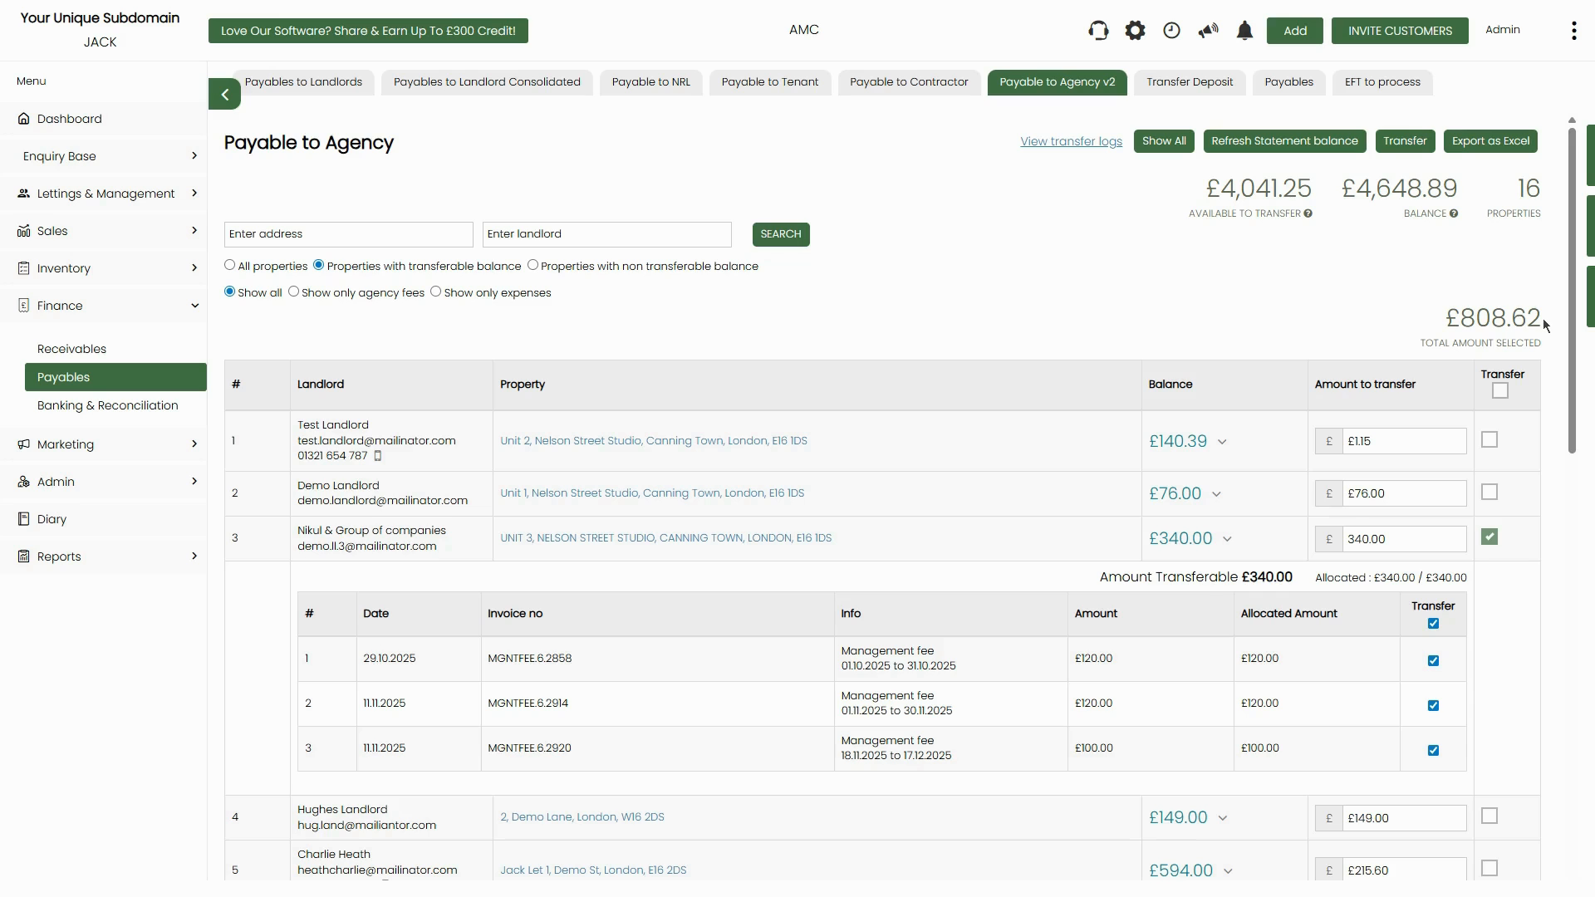

*Figure 8: Expanded row for 'Nikul & Group of companies / UNIT 3' — shows 3 individual management fee invoices (£120.00, £120.00, £100.00) making up the £340.00 balance, each with its own Transfer checkbox and Allocated Amount*

**📌 Note:** The Allocated Amount column shows how much of each invoice has already been allocated against received rent. An invoice is only transferable up to its Allocated Amount. The 'Amount Transferable' and 'Allocated: X / X' summary shown below the expanded row confirms the totals.

# **Making an Agency Fee Transfer**

**Step 1: Adjust the Amount to Transfer (Optional)**

Each row has an editable Amount to transfer field, pre-filled with the full transferable amount. If you want to transfer only part of the available balance for a property — for example, to hold some funds back — simply edit this field before ticking the Transfer checkbox. The system will use whatever amount you enter.

**⚠️ Important:** If the Amount to transfer shows in red (e.g. -£90.00), that property has a negative balance — it owes more than it has received. Do not attempt to transfer from these properties. The Transfer checkbox will not be available for them.

**Step 2: Select Properties to Transfer**

Tick the Transfer checkbox in the far-right column for each property you want to transfer fees from. As you tick rows, the TOTAL AMOUNT SELECTED figure (shown in the lower-right of the page) updates to reflect your selection. You can also tick the Transfer header checkbox to select all visible properties at once.

When you tick a property row, the Transfer button appears in the top-right action bar.



*Figure 9: Properties selected for transfer — row 3 (Nikul & Group of companies) is ticked, the expanded breakdown shows all 3 fee invoices also ticked, and the Total Amount Selected shows £808.62*

**Step 3: Click the Transfer Button**

Once you have selected all the properties you want to transfer from, click the green Transfer button in the top-right action area. This opens the Mark as transferred dialog.

**Step 4: Complete the Mark as Transferred Form**

The dialog shows the Total amount available to transfer for your selection. Fill in:

* Payment date — The date of the transfer. Pre-filled with today's date; edit if needed.
* Payment method — Select the payment method (e.g. Bank Transfer).

The dialog also confirms the Total amount available to transfer so you can verify before submitting.

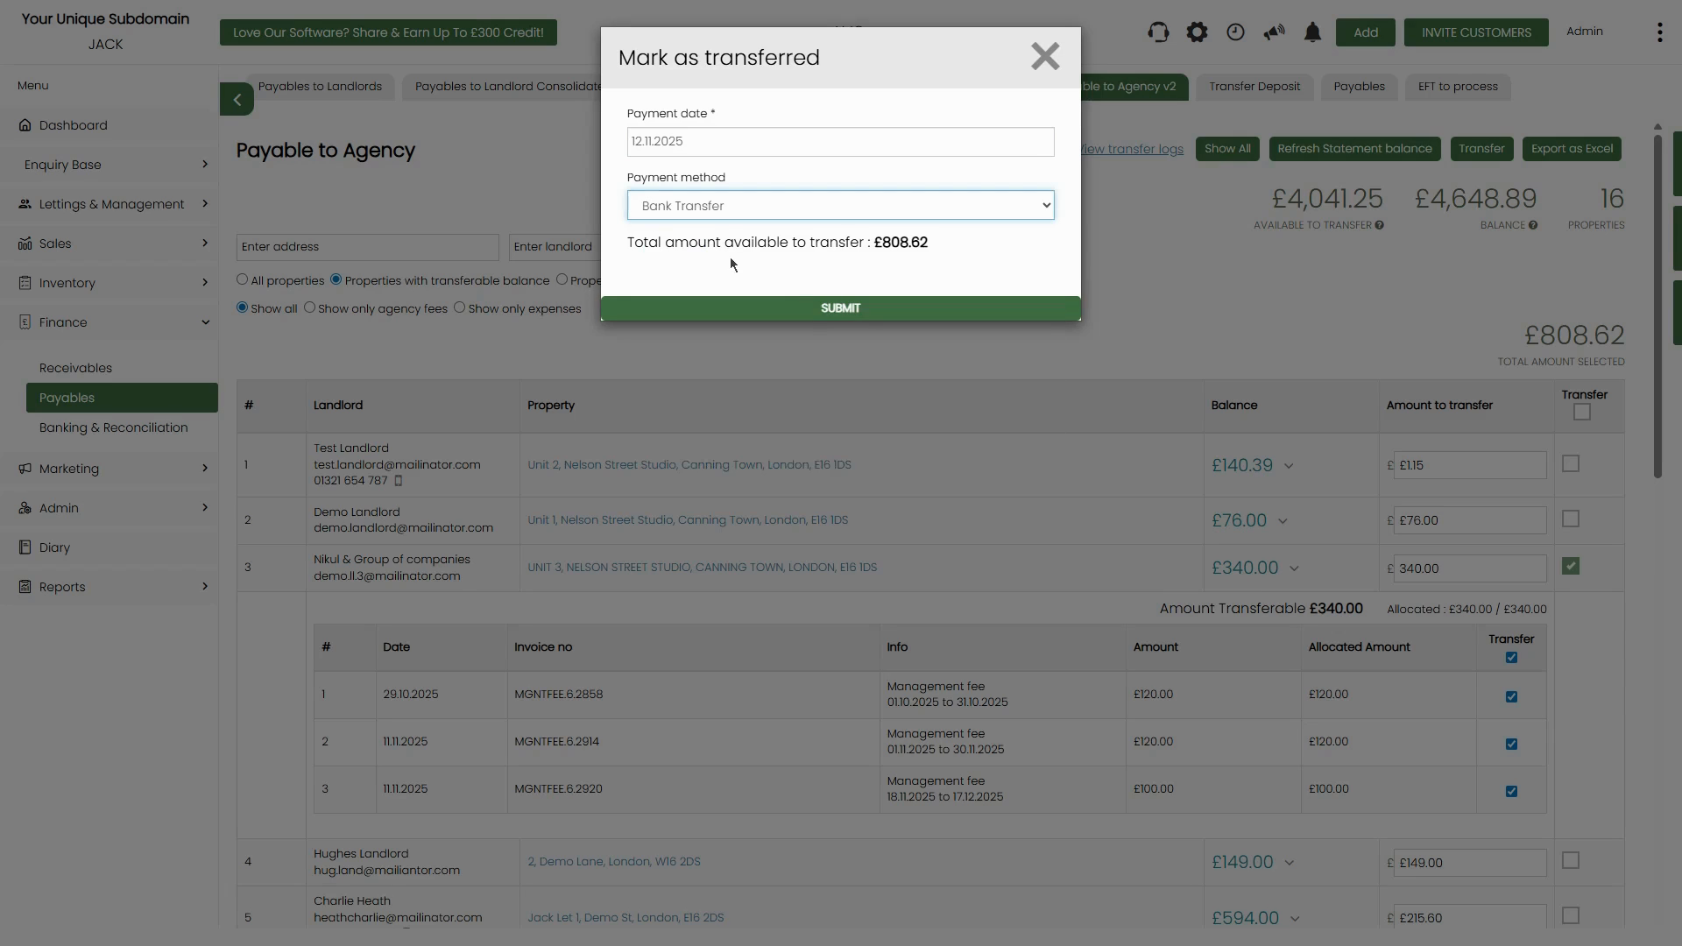

*Figure 10: Mark as transferred dialog — Payment date (12.11.2025), Payment method (Bank Transfer), and Total amount available to transfer (£808.62) confirmed before submitting*

**Step 5: Submit the Transfer**

Click the green SUBMIT button. The system will process the transfer for all selected properties, moving the fee amounts from the client property accounts to the agency account. The transferred amounts will be removed from the outstanding Balance and the properties will update accordingly.

**📌 Note:** After submission, you can click 'View transfer logs' (top-right of the Payable to Agency page) to see a full history of all past agency fee transfers, including dates, amounts, and payment methods.

# **Viewing All Properties in the List**

The full list may span multiple pages (use the GOTO / page navigation controls). Scrolling down reveals all properties with their individual balances and amounts to transfer. The bottom of the full list shows a Total row summarising the combined Balance and Amount to transfer across all displayed properties.

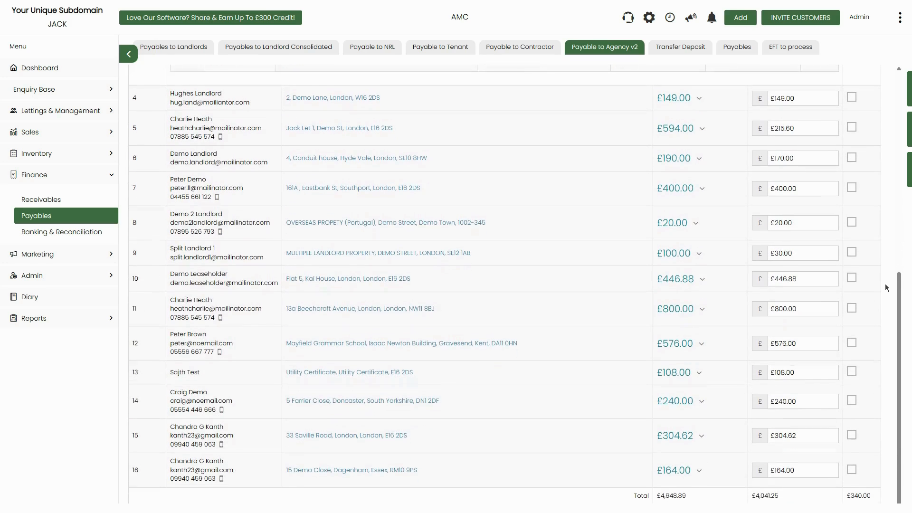

*Figure 11: Scrolled view of the full property list — shows rows 4–16 with varying balances. Row 9 (Split Landlord 1 / Multiple Landlord Property) shows £100.00 Balance but only £30.00 Amount to transfer, illustrating a partial transfer scenario. Total row at the bottom: Balance £4,648.89, Available to transfer £4,041.25*

**📌 Note:** Some properties may show a different Amount to transfer than their Balance. This is normal — it reflects that only part of the total commission owed can be transferred right now, because not all of the corresponding rent has been received yet.

# **Quick Reference Summary**

| **Topic** | **Detail** |
| --- | --- |
| **Where to navigate** | Finance → Payables → Payable to Agency v2 |
| **Page heading** | 'Payable to Agency' — lists all properties with outstanding agency fee balances |
| **Available to Transfer** | The amount already earned and ready to move to your agency account right now (limited by the property's current cash balance) |
| **Balance** | The total outstanding commission/fees owed across all properties, including amounts not yet collectable |
| **Properties** | Count of properties with outstanding agency balances |
| **Loading process** | The page loads all agency payment data on first open — a progress dialog (e.g. '13/41') will appear while loading |
| **Row filters** | All properties / Properties with transferable balance / Properties with non-transferable balance |
| **Content filters** | Show all / Show only agency fees / Show only expenses |
| **Negative Amount to transfer** | Shown in red — means that property owes more than it has received; cannot transfer until resolved |
| **Expanding a row** | Click the expand arrow (▼) on the Balance column to see the individual fee invoices making up that property's balance |
| **Transferring** | Tick Transfer checkbox for each property → Transfer button appears → Mark as transferred dialog → SUBMIT |
| **Adjusting amounts** | Edit the Amount to transfer field before ticking Transfer if you want to transfer a partial amount |
| **View transfer logs** | Click 'View transfer logs' (top-right) to see all historical agency fee transfers |
| **Export** | Click 'Export as Excel' to download the full list for reporting |